•Input :

‘j’

‘w’

‘a’

‘a’

‘s’

‘s’

‘s’

‘d’

‘d’

‘d’

‘w’

‘w’

‘w’

‘w’

‘w’

‘w’

‘a’

‘a’

‘a’

‘a’

‘a’

‘a’

‘a’

‘a’

‘a’

‘a’

•Output:

1.When start

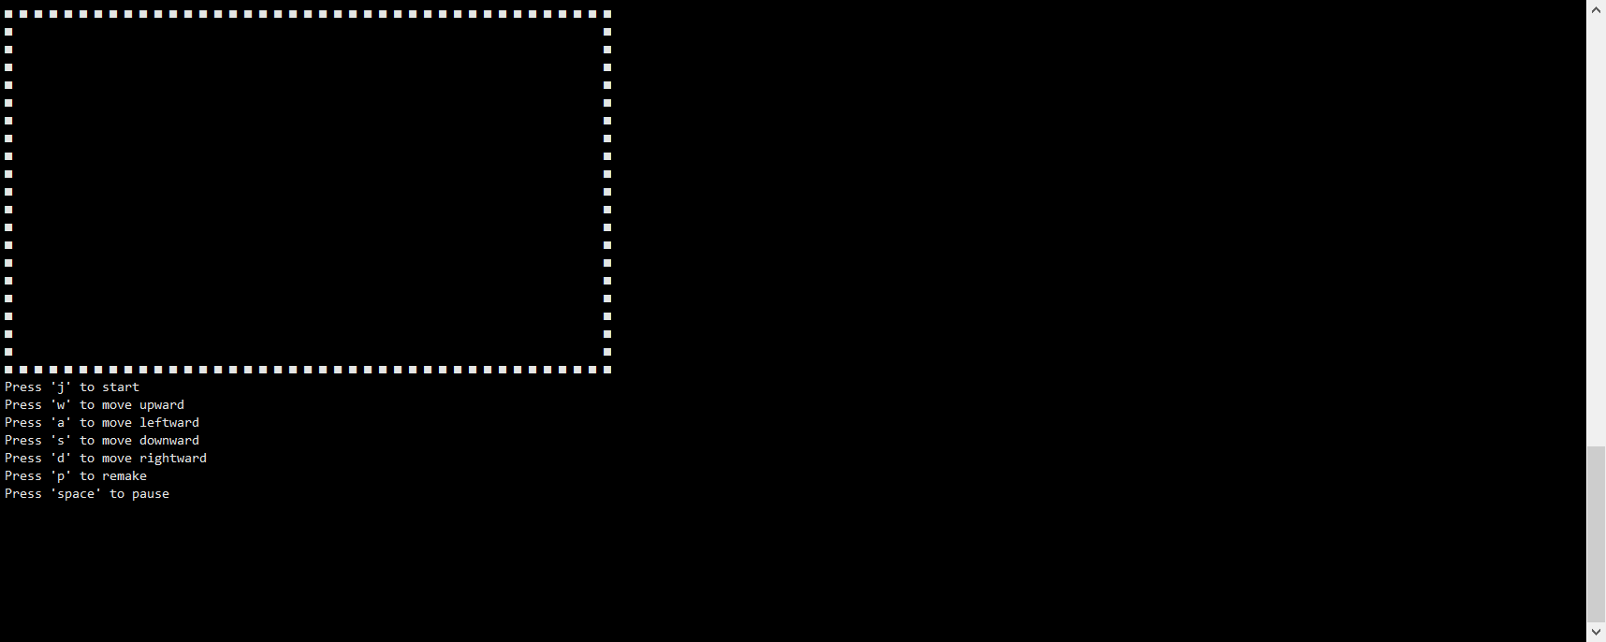

2. During the game process

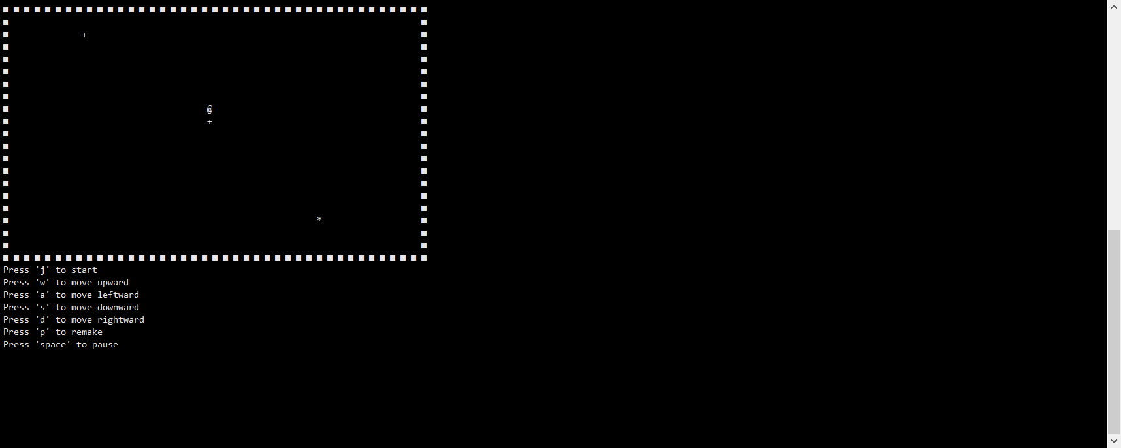

3. At the end of the game

